**Question: 1**

**How to compare two JSON have the same properties without order?**

1. **var obj1 = { name: "Person 1", age:5 };**
2. **var obj2 = { age:5, name: "Person 1" }**

Code:

var obj1 = { name: "Person 1", age:5 };

var obj2 = { age:5, name: "Person 1" };

console.log(JSON.stringify(obj1) == JSON.stringify(obj2));

Output:

false

**Question: 2**

**Use the rest countries API url ->** [**https://restcountries.eu/rest/v2/all**](https://restcountries.eu/rest/v2/all) **and display all the country flags in console**

HTML:

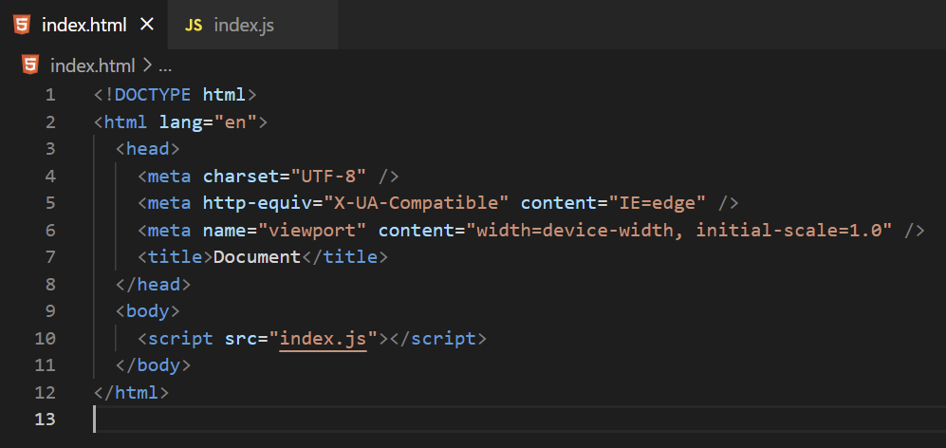

JS: 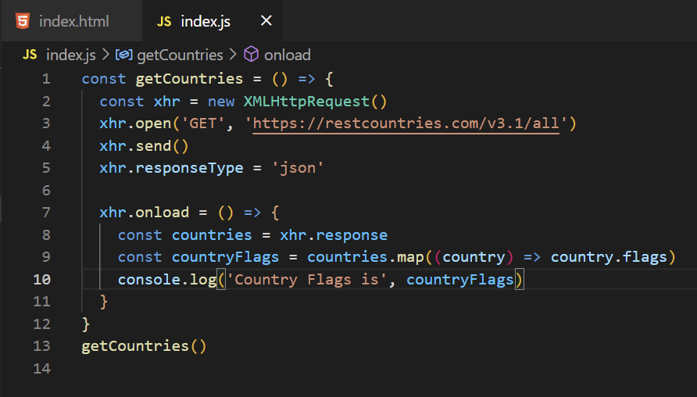

JS Code:

const getCountries = () => {

  const xhr = new XMLHttpRequest()

  xhr.open('GET', 'https://restcountries.com/v3.1/all')

  xhr.send()

  xhr.responseType = 'json'

  xhr.onload = () => {

    const countries = xhr.response

    const countryFlags = countries.map((country) => country.flags)

    console.log('Country Flags is', countryFlags)

  }

}

getCountries()

**Question: 3**

**Use the same rest countries and print all countries name, region, sub region and population**

HTML:

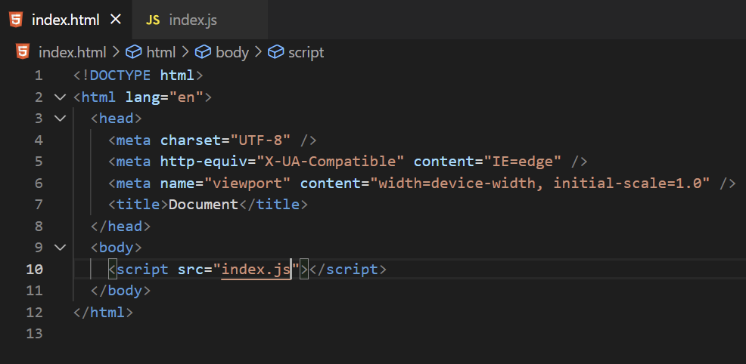

JS:

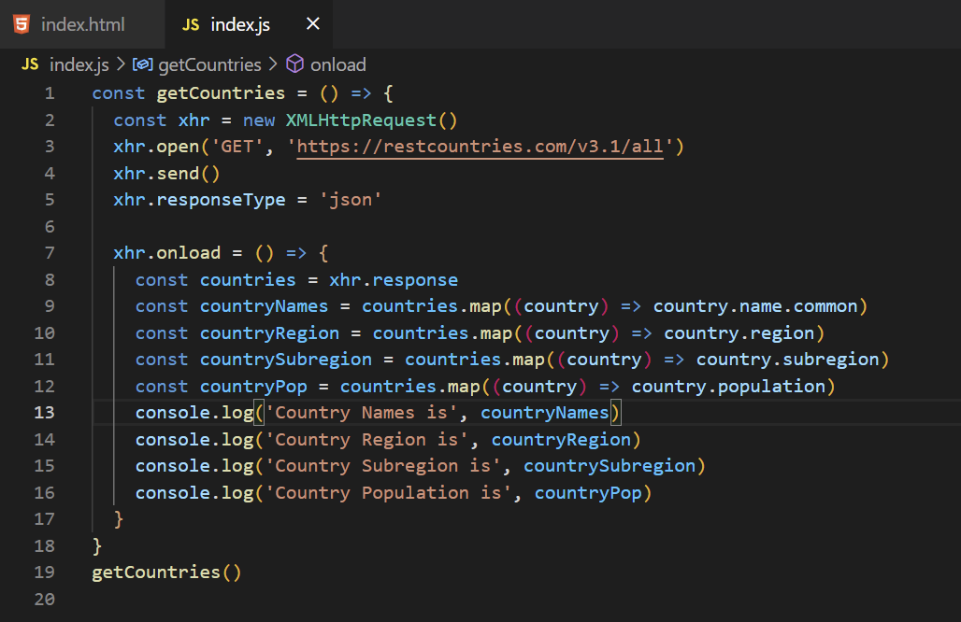

JS Code:

const getCountries = () => {

  const xhr = new XMLHttpRequest()

  xhr.open('GET', 'https://restcountries.com/v3.1/all')

  xhr.send()

  xhr.responseType = 'json'

  xhr.onload = () => {

    const countries = xhr.response

    const countryNames = countries.map((country) => country.name.common)

    const countryRegion = countries.map((country) => country.region)

    const countrySubregion = countries.map((country) => country.subregion)

    const countryPop = countries.map((country) => country.population)

    console.log('Country Names is', countryNames)

    console.log('Country Region is', countryRegion)

    console.log('Country Subregion is', countrySubregion)

    console.log('Country Population is', countryPop)

  }

}

getCountries()

**Question: 4**

[**https://medium.com/@reach2arunprakash/www-guvi-io-zen-d395deec1373**](https://medium.com/@reach2arunprakash/www-guvi-io-zen-d395deec1373)

**Task 1: Simple programs todo for variables**

**1. Declare four variables without assigning values and print them in console**

Code:

let a;

let b;

let c;

let d;

console.log(a, b, c, d);

Output:

undefined undefined undefined undefined

**2. How to get value of the variable myvar as output**



Code:

var myvar= 1;  
 console.log("myvar");

Output:

1

**3. Declare variables to store your first name, last name, marital status, country, and age in multiple lines**

Code:

var firstName = "William"

var lastName = "John"

var maritalStatus = "Single"

var country = "USA"

var age = 27

**4. Declare variables to store your first name, last name, marital status, country, and age in single lines**

Code:

let firstName = "William",

lastName = "John",

maritalStatus = "Single",

country = "USA",

age = 27

**5. Convert string to integer**

* **parseInt()**
* **Number()**
* **Plus sign(+)**

Code:

parseInt() method: let a = "10";

let b = parseInt(a);

console.log(`value is ${b}`);

Number(): let c = "20";

let d = Number(c);

console.log(`value is ${d}`);

PlusSign(+): let e = "30";

let f = Number(e);

console.log(`value is ${f}`);

**Task 2: Simple programs todo for operators**

**1. Square a number**

Code:

let a = 7;

let squareNumber = Math.pow(a,2);

console.log(squareNumber);

Output:

49

**2. Addition of 3 number**

Code:

let num1 = 10;

let num2 = 5;

let num3 = 25;

let add = num1 + num2 + num3;

console.log(add);

Output:

40

**3. Celsius to Fahrenheit conversion**

Code:

let celsius = 37;

let fahrenheit = (celsius * 1.8) + 32;

console.log(fahrenheit);

Output:

98.6

**4. Meter to Miles Conversion**

Code:

let meter = 5000;

const miles = 0.0006213712;

let meterToMiles = meter * miles;

console.log(`${meter} meter is equal to ${meterToMiles} miles`);

Output:

5000 meter is equal to 3.106856 miles

**5. Pounds to Kg Conversion**

Code:

let pounds = 200;

const kg = 0.45359237;

let poundsToKg = pounds * kg;

console.log(`${pounds} pounds is equal to ${poundsToKg} kg`);

Output:

200 pounds is equal to 90.718474 kg

**6. Calculate five test scores and print their average**

Code:

let testScores = [351, 426, 652, 582, 467];

let score = 0;

for (let total of testScores) {

score = score + total;

}

let avg = score / testScores.length;

console.log(avg);

Output:

495.6

**7. Calculate Simple Interest**

Code:

var P, R, T, SI;

P = 5000;

R = 3;

T = 5;

SI = (P * R * T) / 100;

Console.log(SI);

Output:

750

**8. Given two numbers and perform all arithmetic operations**

Code:

var a, b;

a = 7;

b = 2;

// Arithmetic operations

add = a + b;

sub = a - b;

mul = a * b;

div = a / b;

mod = a % b;

console.log(`Addition of ${a} + ${b} = ${add}`);

console.log(`Subtraction of ${a} - ${b} = ${sub}`);

console.log(`Multiplication of ${a} * ${b} = ${mul}`);

console.log(`Division of ${a} / ${b} = ${div}`);

console.log(`Modulus of ${a} % ${b} = ${mod}`);

Output:

Addition of 7 + 2 = 9

Subtraction of 7 - 2 = 5

Multiplication of 7 * 2 = 14

Division of 7 / 2 = 3.5

Modulus of 7 % 2 = 1

**Task 3: Simple programs todo for Condition, Looping and Arrays**

**1. Write a loop that makes seven calls to console.log to output the following triangle**

Code:

let triangle = "";

for (let i = 0; i < 7; i++) {

triangle += "#"

console.log(triangle);

}

Output:

#

##

###

####

#####

######

#######

**2. Create an array called foods holds the names of your top 20 favorite foods, starting with the best food.**

Code:

let foods = ["pasta","puri","pongal","keema","pulao","dosa","idly","chicken","mutton","khichdi","briyani","chaat","appam","samosa","chapati","paratha","tikka","crab","fish","corn",];

**3. Foods variable holds the names of your top 20 favorite foods, starting with the best food. How can you find your fifth favorite food? Find the length of your foods array.**

Code:

let foods = ["pasta","puri","pongal","keema","pulao","dosa","idly","chicken","mutton","khichdi","briyani","chaat","appam","samosa","chapati","paratha","tikka","crab","fish","corn",];

console.log(foods[4]);

console.log(foods.length);

Output:

pulao

20

**4. Add your name to the end of the friends array, and add another name to beginning**

Code:

let friends = ["Vikram", "Rahul", "Yuvan"];

friends.push("Arun");

friends.unshift("Kumaran");

console.log(friends);

Output:

['Kumaran', 'Vikram', 'Rahul', 'Yuvan', 'Arun']